IDD Analysis for IT Supply Chain Management System (SCM)

Objective
Supply chain management is a delicate process of trying to balance demand and supply, potentially across the globe, in a way that provides the company with the right combination of cost control, lead times and service level. The goal of this project is to design a web-based SCM Software which allows organizations to effectively fulfill orders by reducing paperwork, automating picking and shipping planning, and automating shipment verification.

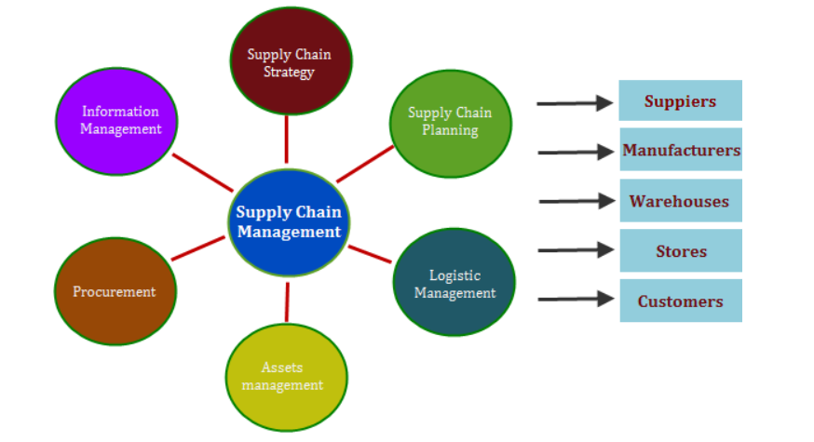

Executive Overview
The purpose of this project is to apply IDD within IT department at an enterprise network device company. This case specifically demonstrates how the IDD (Identify-Define-Design), was used as an underlying framework to establish an IT supply chain management process for this department.

IDD translates users’ needs/expectations into the design of an online SCM system that provides end-to-end support—from supplier and customer collaboration to global inventory management and supply-chain execution. This SCM software solution will help company to automate SCM processes, eliminate inefficiencies, and provide forecast in order to detect and respond to fluctuations.

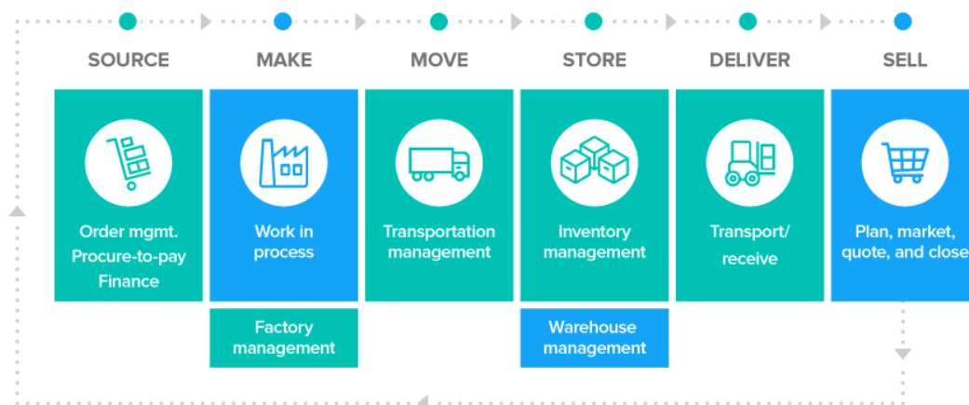

Identify Phase
Three activities are used in identify phase:
1. Develop Project Charter: Use the information provided in the Project
2. Establish Team Ground Rules and team members’ Roles.
3. Develop your team’s project plan for the IDD project.

Project Charter
Project Name: IT Supply Chain Management (SCM) System

Project Overview: Companies with manufacturing operations must be aware of the supply chain at all times, monitoring the performance of suppliers, transportation partners, global competition, delivery times, increasing and changing demand, inventory and customer service. This project offers a full suite of supply chain software solutions that help company manage every link of the supply chain to increase productivity, customer satisfaction, efficiency and profitability.

Problem Statement: The Company does not have a robust formal process for managing SCM, which results in inefficient order fulfillment and high error rates.

Customer/Stakeholders: manufacturing company’s supply chain team.

Goal of the Project: Gain greater visibility in SCM to optimize utilization of resources and labor, improve inventory and shipping accuracy, deliver the perfect order every time, and respond faster to customer opportunities and market fluctuations.

Scope Statement: This project will examine and recommend changes to the major process steps from order acceptance, inventory management, to shipment. The cash management is not in scope of this project.

Projected Financial Benefit(s): Improved productivity, customer satisfaction, reduced wastes and optimized order Fulfillment.

Project Plan
Task | Duration | Start Date | End Date | Predecessors
Identify Phase
Define project charter
Complete risk matrix
Complete stakeholder analysis definition
Develop communication plan
Develop project plan
Establish ground rules
Define Phase
Develop data collection plan

Gather voice of customer (VOC)
Perform benchmarking
Establish baseline
Kano Analysis
Critical-to-Satisfaction
Design Phase
TRIZ brainstorming

Quality function deployment (QFD)
Pugh concept development
Create design workflow
Design Failure Mode and Effects Analysis (FMEA)
Optimize Phase
Quality function deployment

Establish performance targets, project score

Optimize value stream
Gain approval to implement (buy-in from stake)

Develop implementation
Develop communication plan
Develop training plan
Pilot
Cost benefit analysis
Validate
Validate processes
Statistical analysis
Assess performance
Dashboard, scorecards, hypothesis test

Define Phase
Define Phase has below activities:
1. Obtain the Voice of the Customer (VOC): Interview employees to identify users’ thoughts regarding the current SCM management process (i.e., typical uses, advantages, disadvantages, suggested improvements, etc.).
2. Identify Users’ Needs: Translate the information gathered through interviews into needs statements (i.e., requirements that the new system should fulfill).
3. Identify Critical to Satisfaction (CTS) Measures and Targets: Marketing held several focus groups to understand their critical requirements. Extract the CTS criteria from the focus group qualitative data to prioritize the needs new system need to fulfill.
4. Kano analysis: Use Kano analysis to identify the exciting performance-related critical to satisfaction criteria that would provide excitement and be exciters to SCM system, and the basic factors that if missing would be dissatisfied.

Users’ needs (CTQs)
In this survey, respondents were asked to rate the importance of the needs that the SCM system should fulfill using a five-point scale, where a rating of 1 represented “undesirable” and 5 represented “critical.”
Approximately 14 employees participated in this survey, including the SCM team manager, all SCM staffs, and several employees from IT department. The results obtained from the survey were analyzed to determine the most important users’ needs, thus identifying the characteristics/features that the new process for managing SCM changes should fulfill. Analysis of these data using a chi-square test indicated the importance ratings identified through the survey are different from expected values (χ2 = 149.65, p-value = <0.0001).
In terms of the critical to satisfaction (CTS) for this project, the design team selected to focus on the 10 needs that received the largest percentage of responses in the “highly desirable” and “critical” categories (i.e., ratings 4 and 5). Below figure shows the importance weighting assigned to these 10 needs based on median importance ratings. Focusing on these needs in the subsequent phases of this project helped the design team ensure that the final design fulfills the needs of the work environment for which it was created.

Instructions: Please indicate how important the features of IT SCM system listed below are to you, using the following scale:

1. Feature is undesirable. I would not consider an SCM system with this feature.
2. Feature is not important, but I would not mind having it.
3. Feature would be nice to have, but is not necessary.
4. Feature is highly desirable, but I would consider an SCM system without it.
5. Feature is critical. I would not consider an SCM system without this feature.

Please provide the desirability of below SCM features:
1. Order management – The system will check for raw material availability, product manufacturing, and passing the product to the logistics team.
______
2. Order management – The system will monitor the order and track the entire process, and ensure that the product is delivered on time.
______
3. Inventory management - The system will help support inventory concerns such as asset management, replenishment lead time, and future inventory and price forecasting.
______
4. Warehouse management – The system can quickly process transactions such a picking, placing, receiving, and shipping.
______
5. Order Processing – The system provides an automatic process to replenish inventories, generate serial numbers for product shipments, and track inventory costs.
______
6. Transparency - The system serves as a single point of access for its supplier information and its buyer-supplier communities.
______
7. Support new market expansion – This system will accommodate multiple and fluid business models to enable the company to reach international markets
______
8. Transportation and distribution – This system will assist in transportation and distribution such as vehicle-scheduling, load creation and sequencing.
______
9. Supplier tracking – The system can track suppliers’ ability to meet financial, legal, safety, quality and regulations.
____
10. Supplier relationship management – The tool uses interactive production planning, Gantt Charts and simulation to assess the suppliers’ assets and capabilities and compare them with the organization’s business strategy.
______

Voice of Customers (VOC) Matrix
Customer Requirements Questions | Kano Classification | Customer Importance Rating | CTS Metric | CTS Goal
Q1 | Revealed | 5 | Survey Rating (1..5) | >4
Q2 | Revealed | 5 | Survey Rating (1..5) | >4
Q3 | Basic | 5 | Survey Rating (1..5) | >4
Q4 | Basic | 5 | Survey Rating (1..5) | >4
Q5 | Revealed | 5 | Survey Rating (1..5) | >4
Q6 | Excitement | N/A | Yes/No | Yes
Q7 | Excitement | N/A | Yes/No | Yes
Q8 | Excitement | 3 | Survey Rating (1..5) | Have
Q9 | Excitement | 3 | Survey Rating (1..5) | Have
Q10 | Excitement | 3 | Survey Rating (1..5) | Have

Design Phase
Activities in design phase are as below:

- Generate potential design ideas: Use brainstorming, lateral thinking, parallel thinking, and benchmarking for concept generation, and then organize design ideas in a process flow.
- Develop preliminary design: Apply Quality Function Deployment (QFD) to translate customer needs (VOC) into Functional Requirement (FR), then Design Parameters (DP), and then Process Parameters (PP) using one or more inter-related matrices.
- Development process map for process: Design workflows are generated based on the process flow.
- TRIZ: Use TRIZ Segmentation principle to create UML software design diagram.
- Pugh concept development and selection process.
- FMEA: Apply FMEA to test driven software development process. Create a software test plan based on the FMEA result.

Design ideas generation
In the Design phase, brainstorming and benchmarking were used to generate high-level, potential design ideas. This work involved a total of 11 interviews to collect ideas from internal as well as external informants in the SCM field and beyond. The people interviewed included SCM staffs, packaging staffs, and IT staffs, as well users of SCM systems from other industries, including manufacturers and suppliers. In these interviews, participants were asked to describe the methods they use to track and communicate order changes/updates, how these methods work, and the advantages and disadvantages associated with these methods. The information obtained from these interviews was categorized in process flow.

• Generating seven design concepts that meet customer requirements.
• Evaluating superior concepts and superior technology to beat the market.
• Analyzing and studying feasibility of superior concepts—looking at the competitors
• Adding value to the design by thinking “outside the box”

SCM Process Flow

After evaluating product design concepts, below process flow were generated:
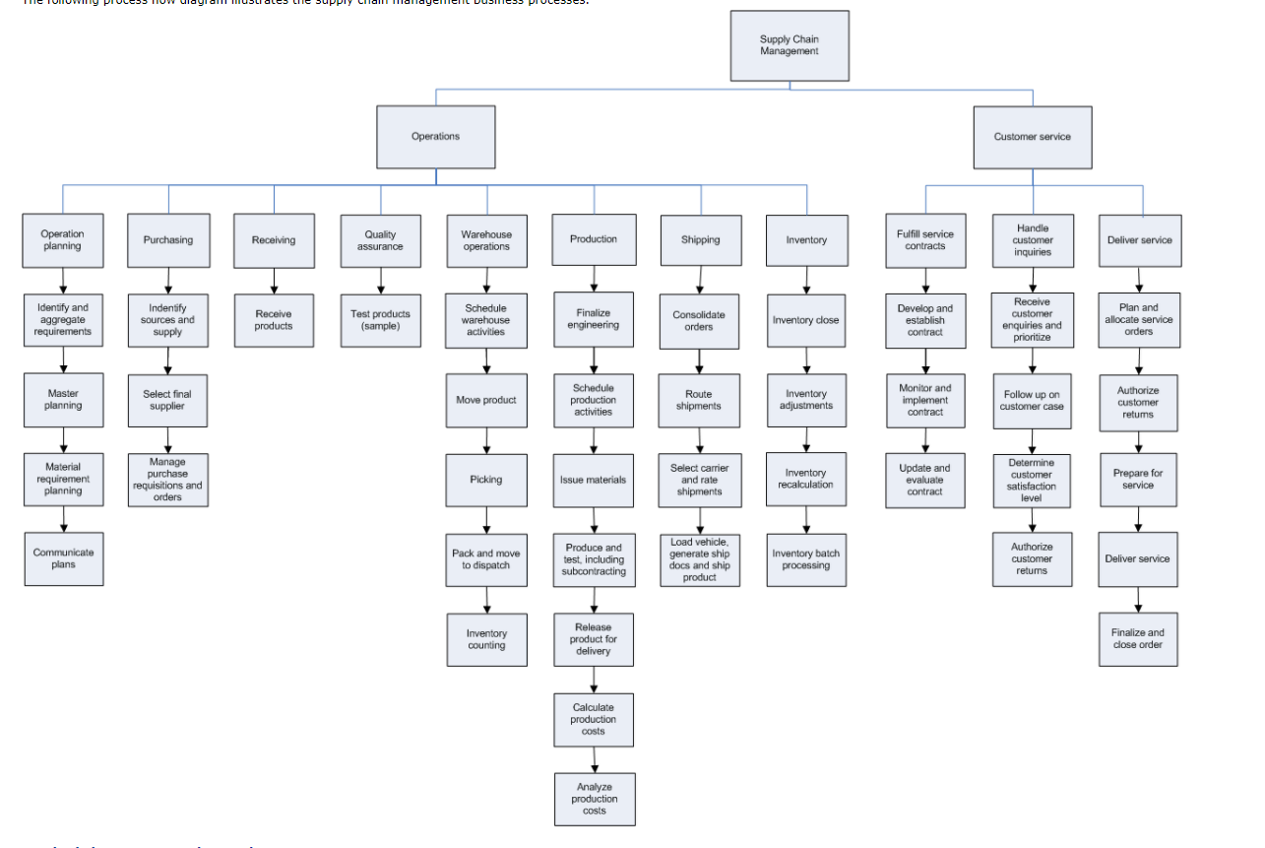

Quality Function Deployment (QFD)
The conception generation results were attained through the House of Quality (HOQ) analysis. Through this iterative process, the group developed detailed functional specifications with functionality, usability, and constraint descriptions. Below are steps to build house of quality:

Step 1: List the customer requirements with their importance rating on a scale of 1 (low) to 5 (high).
Step 2: List the technical process requirements that will affect more than one of the customer requirements, in the process.
Step 3: Compare the two (customer requirements to the technical customer requirements) and determine the relationships, identifying a strong relationship (9), medium relationship (3), low relationship (1), or no relationship (blank).
Step 4: Obtain the weighting and ranking for the process requirements.
Step 5: Carry the weighting to the second House of Quality. Place the process requirements on the left vertically, and identify the process components that will help to meet the process requirements.
Step 6: Determine the relationships between the process requirements and the process components.
Step 7: Carry the weighting to the third House of Quality. Place the process components on the left vertically, and identify the process metrics that measure the process components.
Step 8: Determine the relationships between the process components and the process metrics.

Design Workflow Process Map
After process design selection and evaluation, below design process maps were generated:
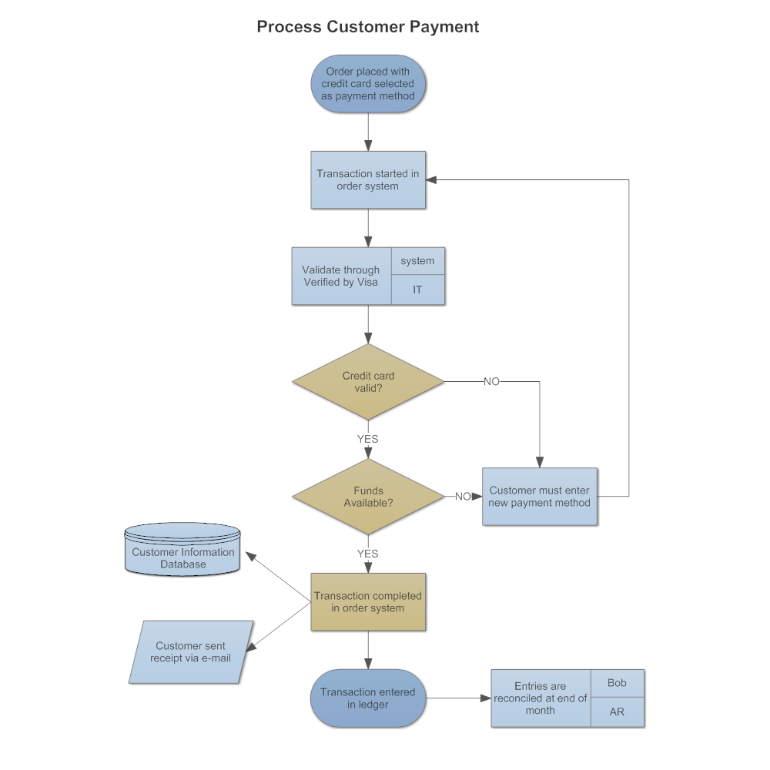

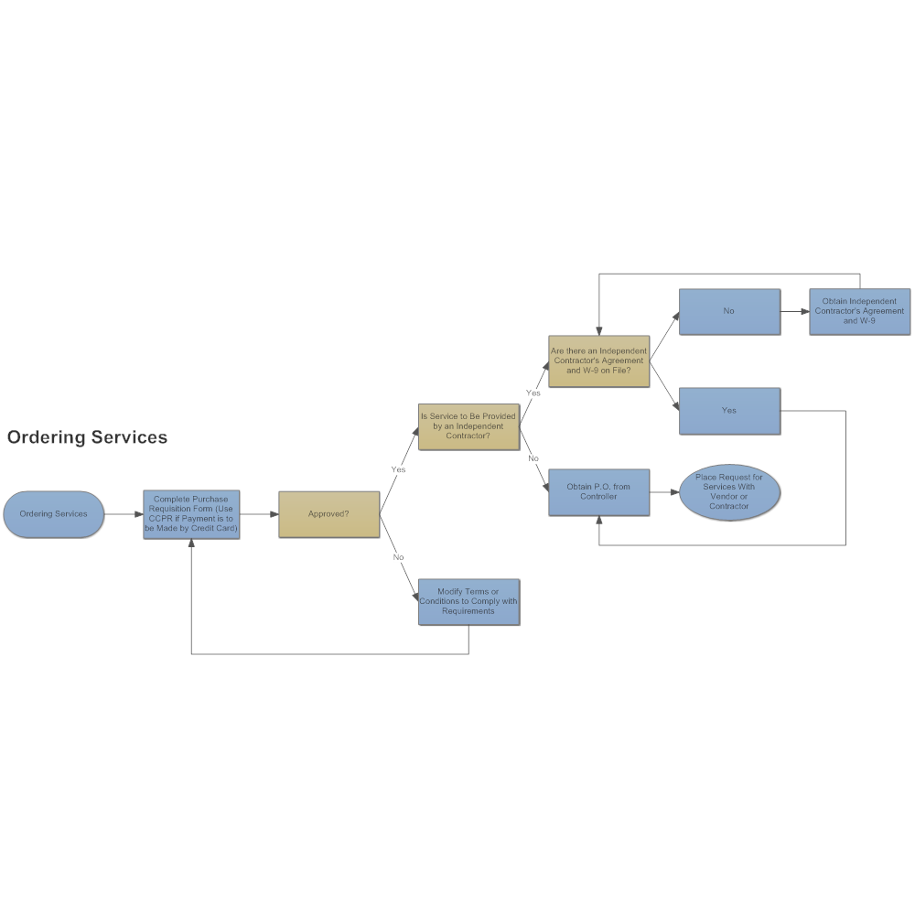
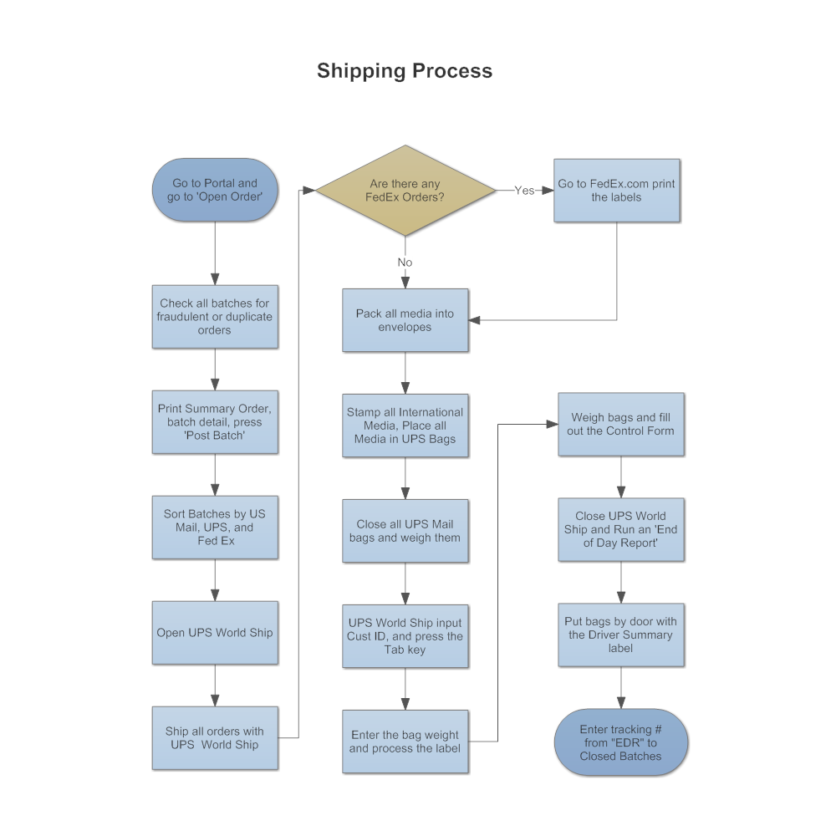

TRIZ –segmentation Principle
After separating functionality to independent components as shown in the process maps above, create a software design diagram (UML) to make each function loosely coupled and highly cohesive.
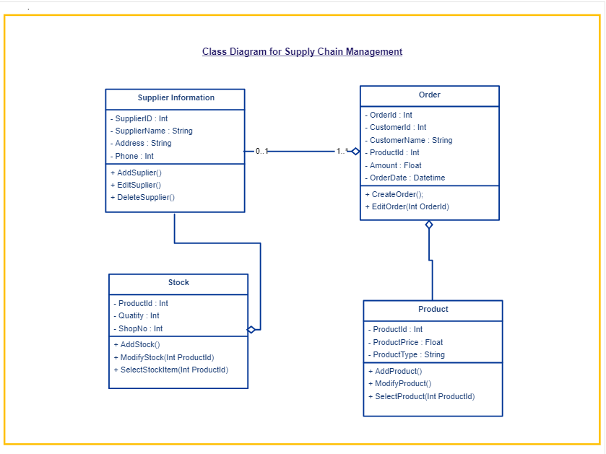

Pugh Matrix
Establish a baseline solution (DATUM): Develop a SCM system for the company.
Alternatives: Buy commercial software for the company.
- Buy from Oracle
- Buy from SAP

The Pugh matrix result shows that developing their own provides more customized functions the company is looking for than buying commercial ones.

Failure Mode and Effect Analysis (FMEA)
The team incorporated test driven software development process with design failure mode and effects analysis (FMEA). That means, the failure modes, failure effects, and failure causes must be analyzed before coding process starts. The system boundary were defined in this process. The negative and positive interactions between a component and its surrounding components were captured. Also, the problem severity rating, potential causes, and occurrence rating were all prioritized by risk priority number (RPN) in this process. Once potential defects were identified and ayalyzed, the software test plan and test cases were created based on FMEA result.

Summary
The work completed in this project illustrates the effective use of the DFSS methodology to create an IT SCM system for an enterprise. By using the IDD process and associated tools, users’ needs were identified and a new process was established that effectively fulfilled the needs of the work environment for which it was designed. The use of this structured design approach achieved several positive outcomes for the organization overall and for the SCM department.

Throughout the DFSS process, all members of the SCM department worked together closely to improve the communication of supply chain management. Because SCM staffs are the users of the new system and they helped to design it, little resistance to using the new system was encountered during implementation. Hence, new SCM system has become an integral part of the daily work processes of the SCM department.

Several months after implementation, the SCM system continues to be successfully used by the entire SCM department, including their external partners. The successful implementation of a complete design solution has led to the effective SCM within the company. As a result, the new system has had a positive impact on reducing costs and wastes, as well as improving productivity and customer satisfaction for the organization as a whole.

